**EDGE INTELLIGENCE**

**LAB-4**

Name: R.Amarnath

Roll no: 25MML0051

**Embedded Vision ML Pipeline in Edge Impulse**

**Step 1: Data Acquisition**

Collect and label image data using the Data Acquisition section in Edge Impulse.

Bottle

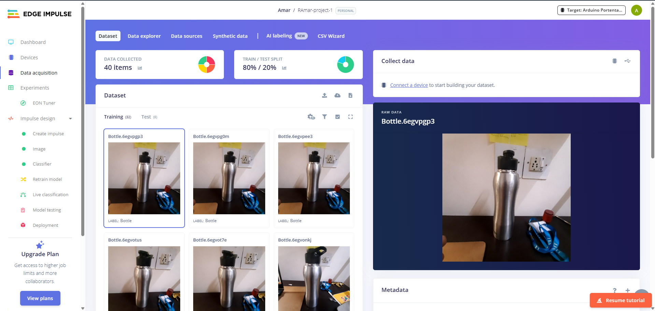

Keys

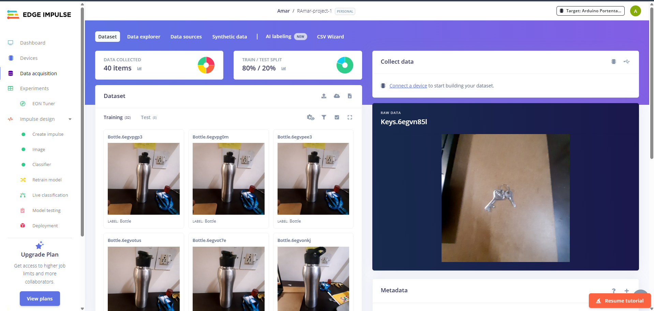

Pen

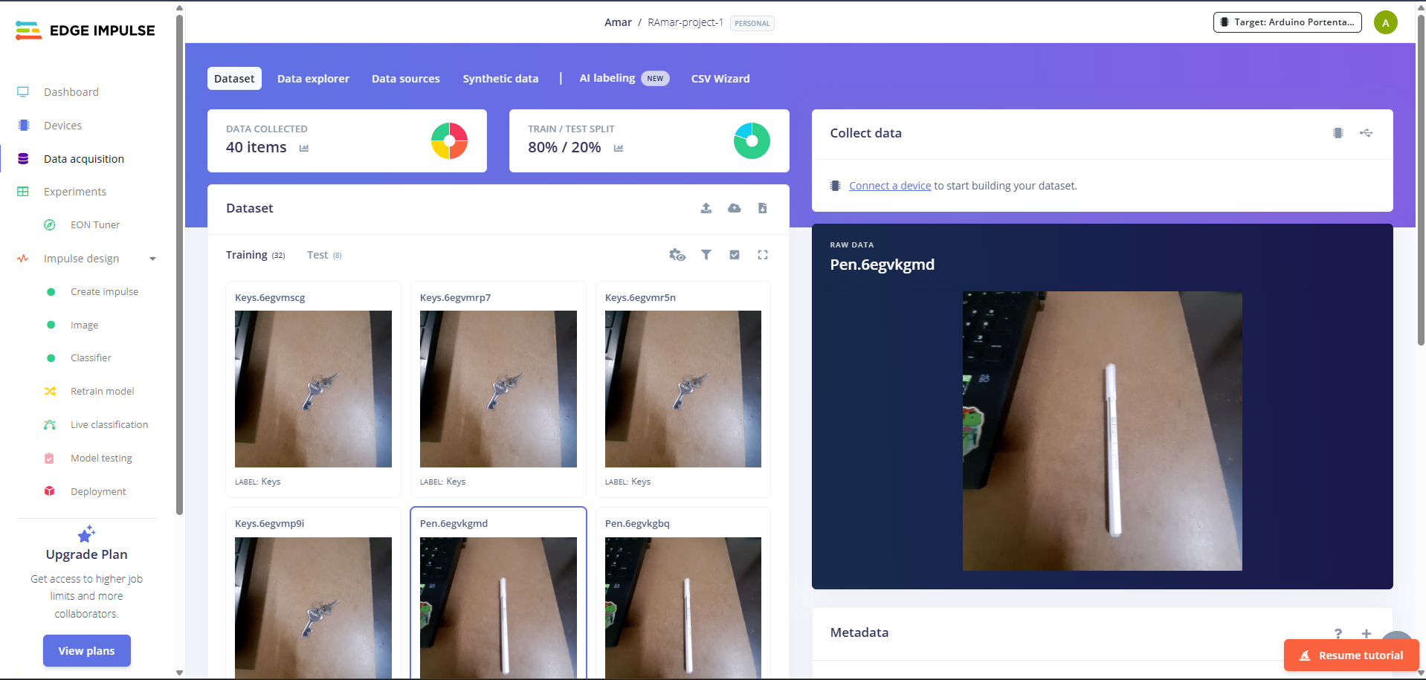

Book

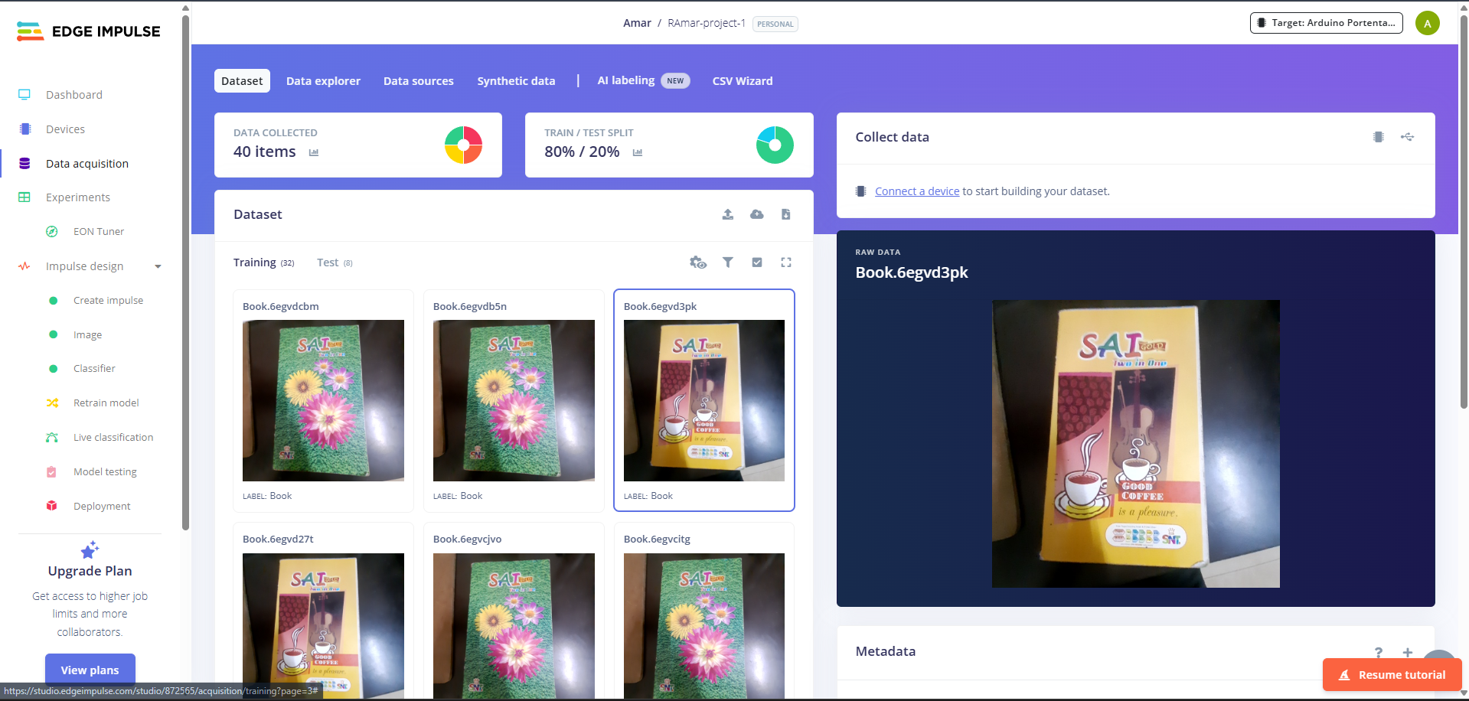

**Step 2: Create Impulse**

Configure the impulse by selecting image input size, preprocessing block, and learning block.

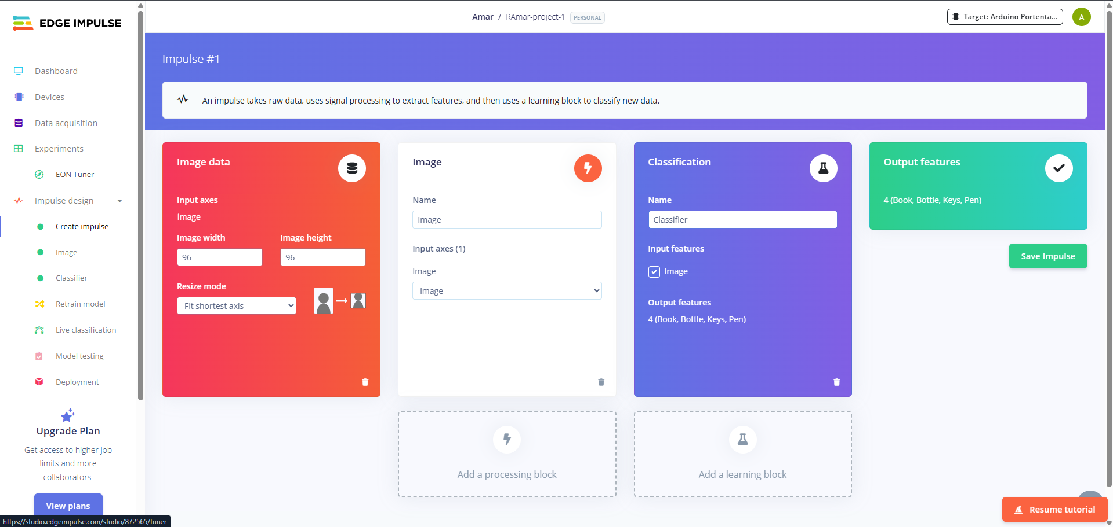

**Step 3: Image Preprocessing**

Resize and preprocess images using the Image block.

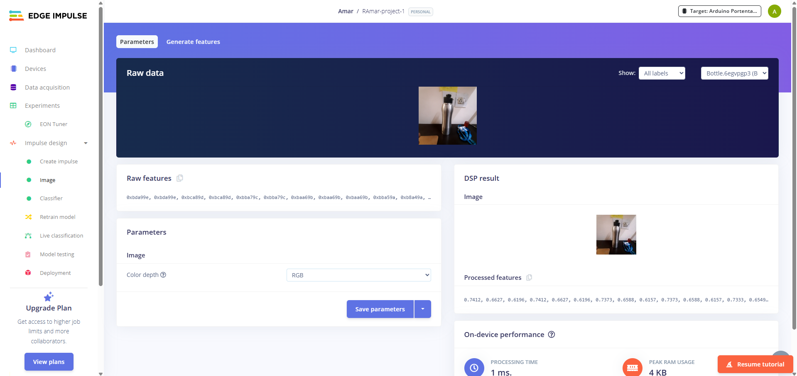

**Step 4: Feature Generation**

Generate features from the pre-processed images

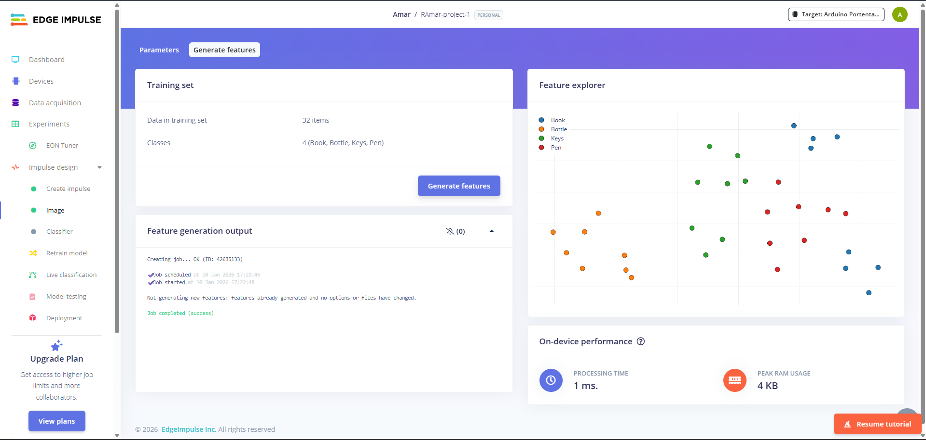

**Step 5: Transfer Learning & Model Testing**

Train the model using Classifier & evaluate the trained model using test data.

